Correlation Measurement

Name
Institution
Course
Instructor
Date

Correlation Measurement
Correlation analysis is a pseudo research approach where an objective is to find two parameters, analyze and evaluate their statistical association, and do so without any other variables. The infant and perinatal inputs to reading activities and their impact on language and cognitive growth are the study subjects (Deckner et al., 2006). In addition to that, the variable being measured by this correlation are early collaborative reading activities and later linguistic and nascent cognitive results.
Moreover, although cooperative learning and emerging new literacy are not the principal aim of the research, findings and acceptance criterion to these mechanisms were included in the data gathering guidelines when youngsters were on average 18 (spectrum = 17.6–18.7), 27 (scope = 26.6–27.6), 30 (scope = 29.5–31.6), and 42 (spectrum = 41.5–44.2) years old to resolve the existing objectives of the study (Deckner et al., 2006). All youngsters were assessed for speech and communication progress at eighteen months, 27, and 30th months. In addition to that, the research is a Pearson's r correlation that evaluates the linear association between two variables. In this case, the infant and parental inputs to learning activities and the impact on language development and cognitive development (Deckner et al., 2006). Based on the results, there is a solid correlation between the variables in question. Youngsters' enthusiasm was 3.0 on a 1–5 score when viewed during collaborative storytelling, indicating that most infants were somewhat enthusiastic (Deckner et al., 2006). Besides, on the early literacy methods survey, all parents stated that collaborative learning was a prevalent and lengthy activity. They appeared to help offer a literacy-rich setting for their youngsters, as evidenced by the high percentage of children's literature in many of the homes.
To sum it up, the correlation between the variables in this research is positive since the variables move towards the same course, meaning cognitive development and enthusiasm between the youngsters increased when the parents engaged them in collaborative reading. In addition to that, the significance level in this study is five, and the result obtained was three on a scale of 1-5, meaning this correlation is statistically significant since the p-value falls between the recommended less than or equal to the significance level of five.
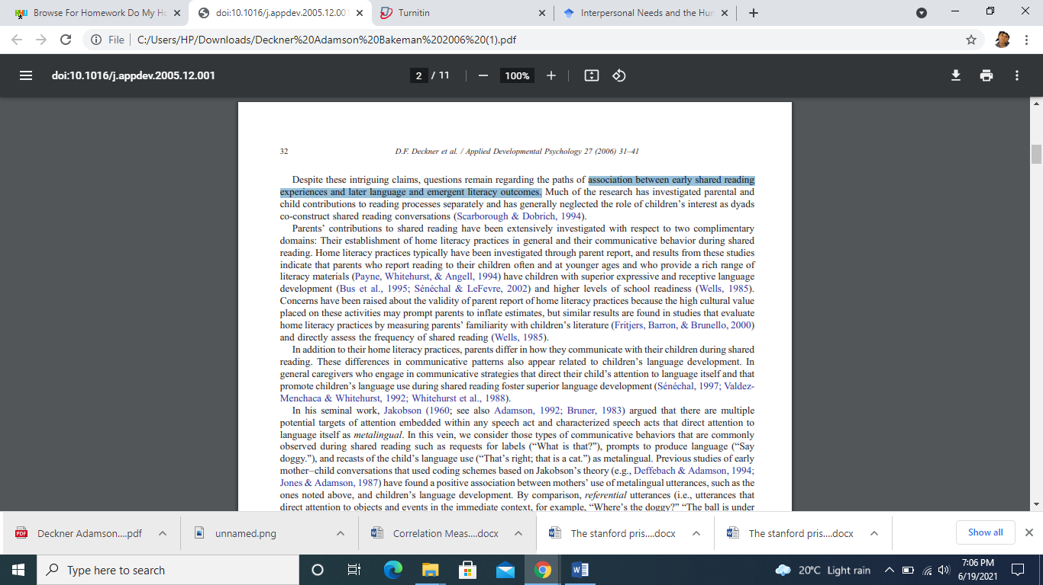

Reference
Deckner, D. F., Adamson, L. B., & Bakeman, R. (2006). Child and Maternal Contributions to Shared Reading: Effects on Language and Literacy Development. Journal of Applied Developmental Psychology, 27(1), 31-41.

